Installation
Double Click NextClaimerSetup_<v>.msi file you downloaded to start the installation.
If a Windows protected your PC screen by Microsoft Defender SmartScreen is prompted, click ‘Run Anyway’ to continue the installation.
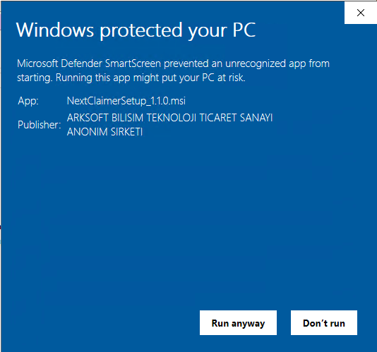
When Welcome Setup Wizard appeared, click to Next button,
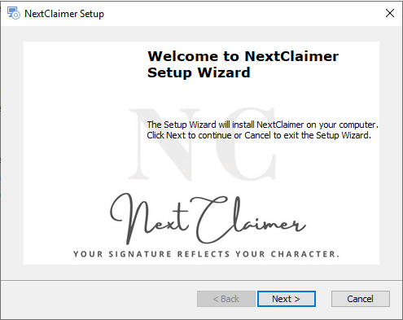
You may specify a installation folder or leave it with as it’s and click ‘Next’ and Install buttons
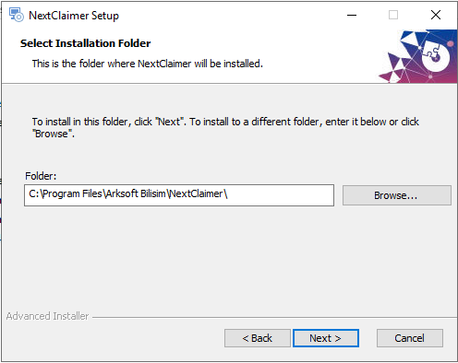
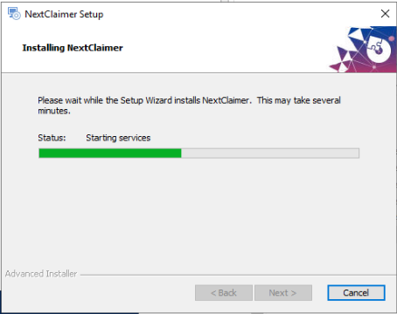
NextClaimer requires Microsoft Edge Webview2 Runtime component to be installed on the server. The setup package automatically starts the installation of the Microsoft Edge Webview2 Runtime package if it’s not exist on the server.
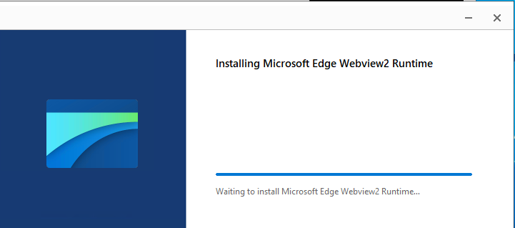
If It’s already installed you may get Installation Failed of that component. It’s normal, just click to ‘Close’ button to complete the installation.
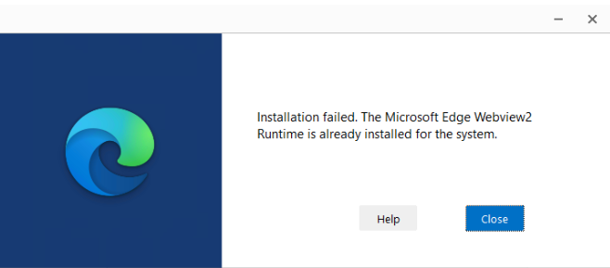
And Click ‘Finish’ button to close the setup wizard.
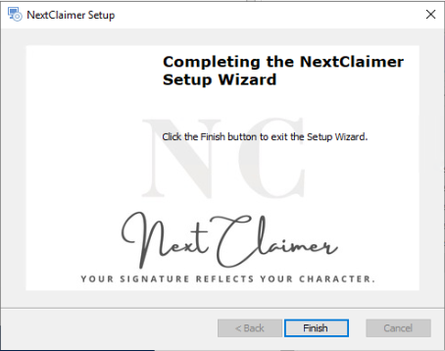
Repeat installation steps on other Exchange Servers.

Initial Configuration of NextClaimer
Once NextClaimer setup has been installed to all Exchange Server in the organization, you may start to configure the tool on any of the Exchange Server.
To start configuration of Exchange Server,
Start NextClaimer Console by double clicking to the NextClaimer icon on either the desktop or start menu.
Click to Settings Button to start initial configuration.
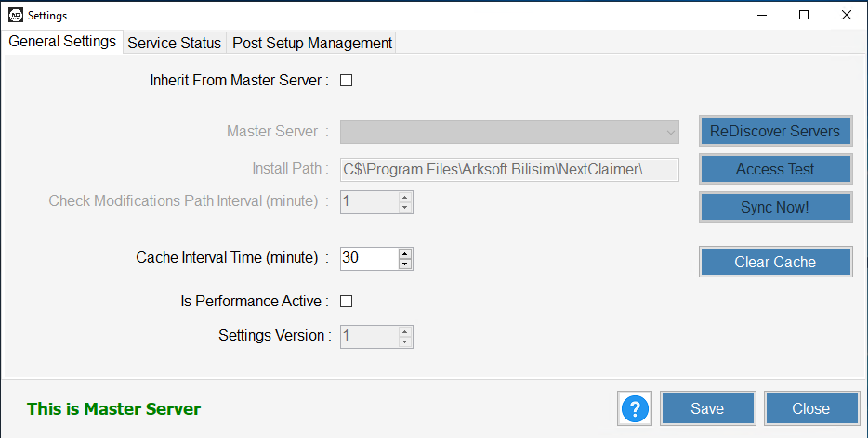
Click to Post Setup Management TAB
Click to ReDiscover Servers button to discover the exchange servers in the environment.
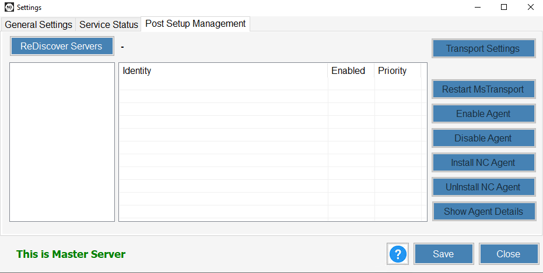
Once the list of the servers has been appeared on the left side, double click to the server you want to configure. It will list the transport agent installed on that server.
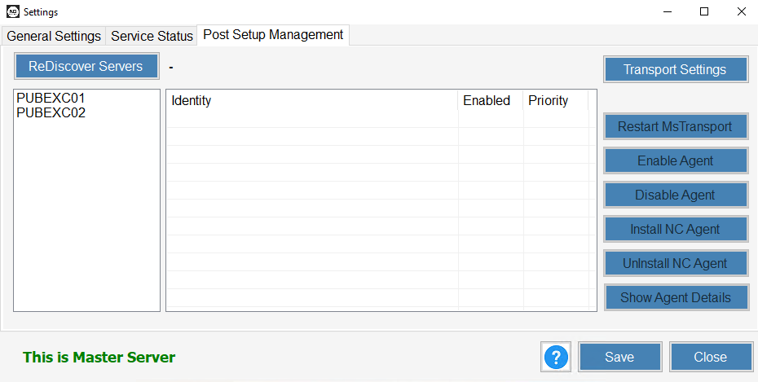
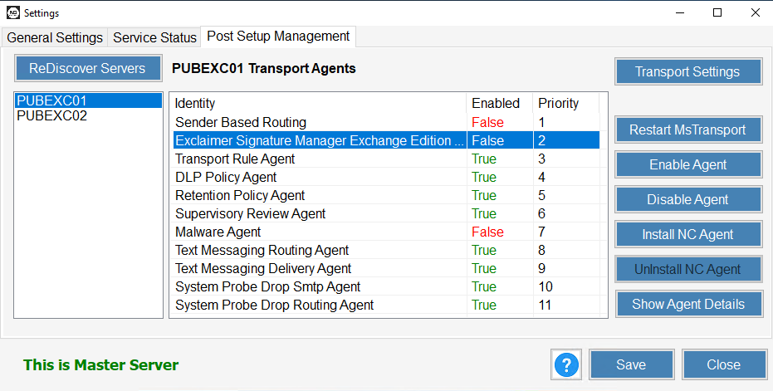
Click Install NC Agent on the right side of the screen to install NC transport agent on that server and confirm the installation.
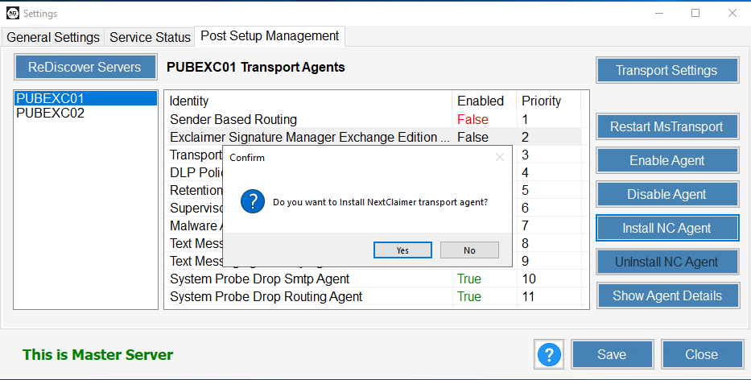
Repeat the installation of the NC Transport agent on the other servers that NextClaimer has been installed by just double-clicking to the server name on the left list and clicking ‘Install NC Agent’ button.
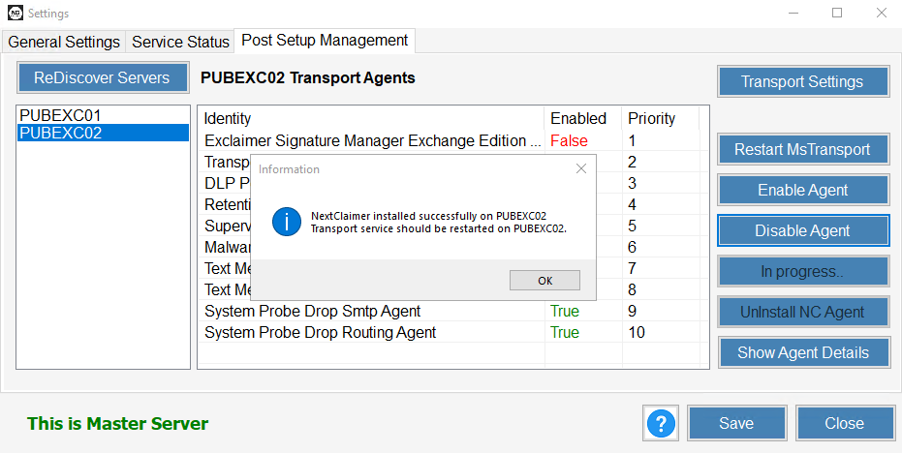

Licensing
NextClaimer is being licensed to the Exchange Environment and a license file is enough to all Exchange Servers in the environment.
Download your license.json file generated by your License Key to a shared area and Import it through ‘Import From File’ button
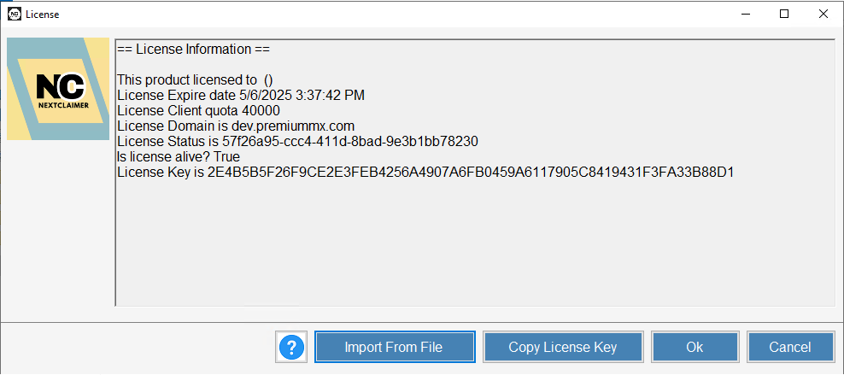
Note: If you didn’t obtain the license file, just ‘Copy Licence Key’ and email us to get your license file.
Configurations on other Exchange Servers
To synchronize all settings and licencing information from the initially configured server, just click to ‘Inherit From the Master Server’ check box and select the Server Name from the list.
All templates, rules, and licensing information will be synchronized from the Master Server.
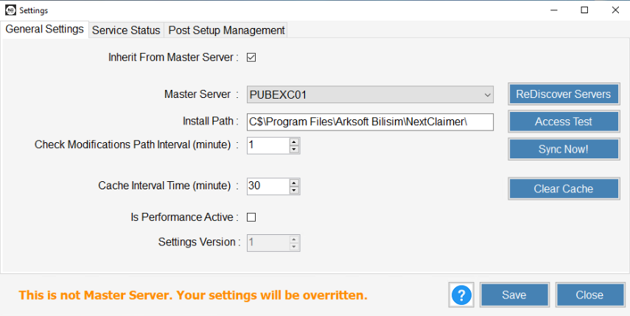

Configure Your Signature Rules
Once you have installed NextClaimer on all servers, click Rules to create the signature/disclaimer rules for your needs
https://NextClaimer.com/guides/rules.aspx

