How to Uninstall NextClaimer from an Exchange Server?
The NextClaimer transport agent should be removed from Transport Service first. You may use NextClaimer’s Settings page to complete this task.
Through NextClaimer ConsoleOpen NextClaimer Console,
Click Settings button and click Post Setup Management tab
Double Click to the server on the left side that you want to the NC Agent uninstall from.
Press ‘Uninstall NC Agent’ button on the right side of the screen.
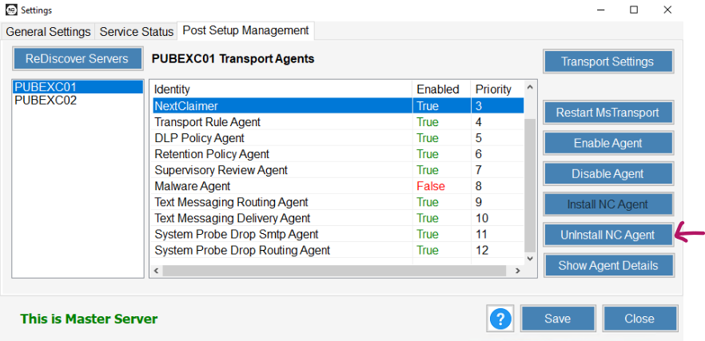

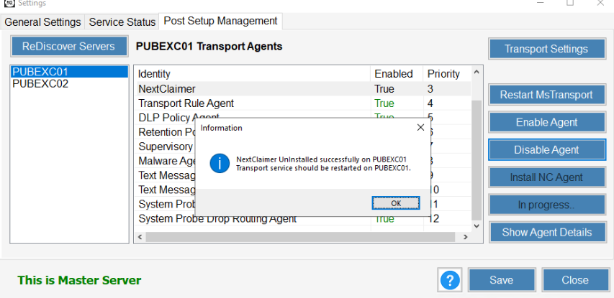
And press Restart MsTransport button to restart the service on the server.
If you want to uninstall the agent from other Exchange Servers, double click to the server name on the left menu and complete the same steps.
Through Exchange Management Shell
You can do this task from Exchange Management Shell;
Open Exchange Management Shell and type following command
Uninstall-TransportAgent NextClaimer
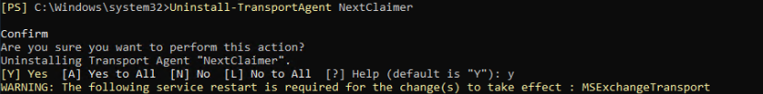
Restart-Service MsExchangeTransport (with Administrative Rights)

Connect all other servers and complete the same steps.

