NEXTCLAIMER UPGRADE
1-) On the master server, go to the directory where the Next Claimer application is installed (e.g., C:\Program Files\Arksoft Bilisim\NextClaimer). To ensure that the rules and signatures you’ve created remain intact after the update, back up the Data folder. The Data folder gets overwritten with each new installation.
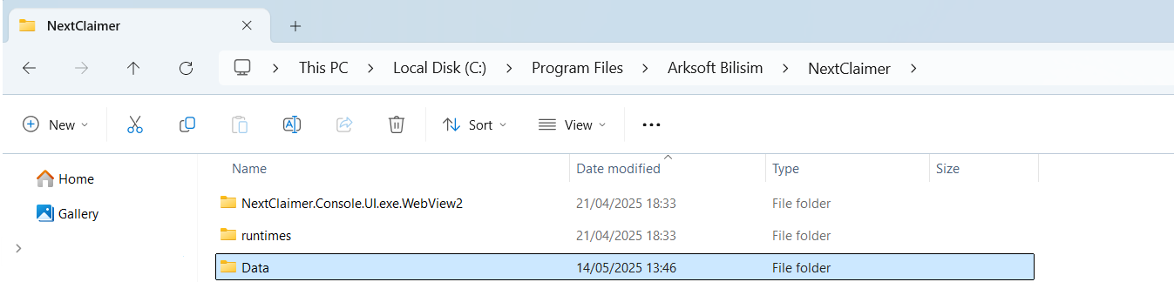
NOTE: The removal process must begin on the slave servers; only after it has been removed from all slave servers should you remove it from the master server.
2-) Log in to one of the slave servers and launch the NextClaimer Console UI. In the Settings screen, go to the Post Setup Management tab. Click the ReDiscover Servers button to populate the server list, then select the server you’re on. In the center pane, choose the NextClaimer transport agent. Next, click the UnInstall NC Agent button on the right. When you see the confirmation message indicating the NC Agent has been removed, click Restart MsTransport to notify and restart the Microsoft Transport service.
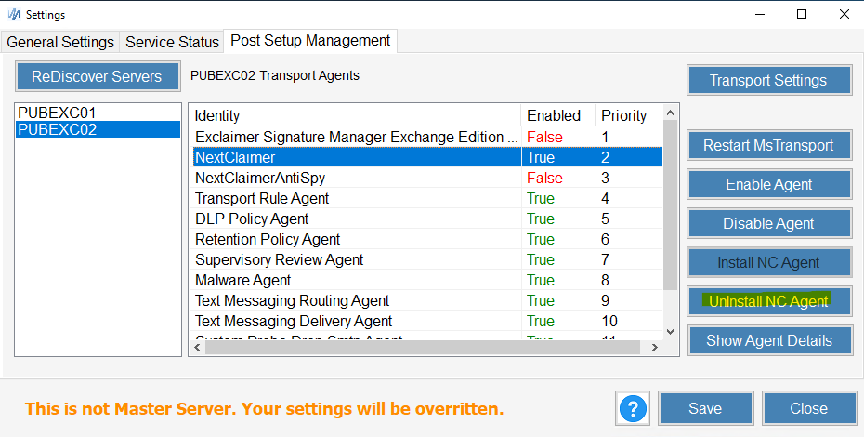
3-) Go to the Add or Remove Programs screen. Locate the NextClaimer application and uninstall it—when the warning dialog appears, click “Yes” to remove the application.

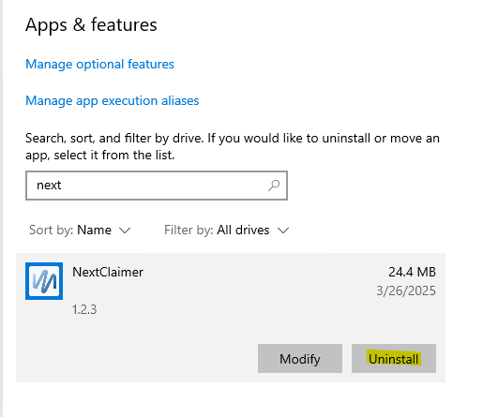

4-) Perform this removal on each slave server in turn. Once the removal is complete on all slave servers, repeat the same process on the master server to uninstall the application.
== NOTE: Installation must be done first on the master server and only then on the slave servers. ==
5-) On the server you’ve designated as master, run the downloaded NextClaimer setup file and complete the installation. Next, restore the Data folder you backed up: navigate to the NextClaimer installation directory (e.g., C:\Program Files\Arksoft Bilisim\NextClaimer) and overwrite the Data folder created by the setup.
6-) Launch the NextClaimer Console UI. In the Settings screen, open the Post Setup Management tab. Click ReDiscover Servers to refresh the server list, then select the server you’re on. On the right, click Install NC Agent, and when prompted, click Restart MsTransport to notify the Microsoft Transport service. Perform this installation first on the master server, then on each slave server.
(Note: You only need to overwrite the Data folder on the master server; it will automatically propagate to the slave servers.)

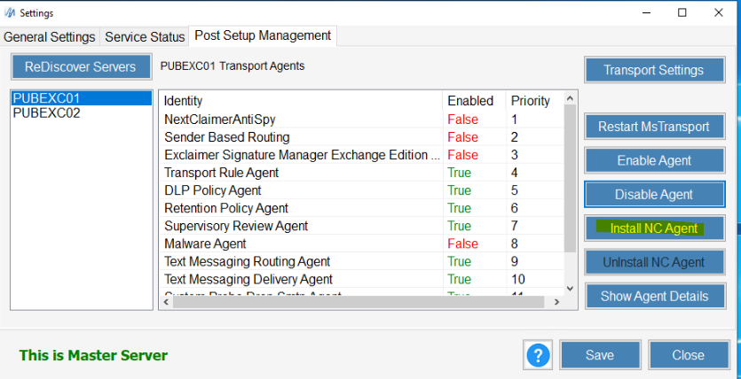

7-) Go to each server you want to make a slave, open the Settings screen, and then select the General Settings tab. Check the “Inherit from master” box and specify the Master Server.

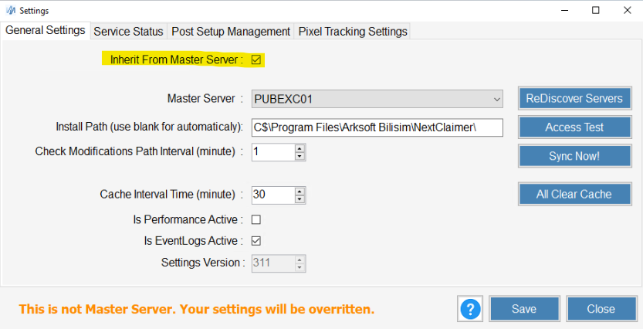

8-) By following these steps, you can successfully upgrade your NextClaimer application to the new version while preserving the rules, actions, and settings you previously created.

